**GIT**

**2. Git - HOL**

Create a **“.log”** file and a **log folder** in the working directory of Git. Update the **.gitignore** file in such a way that on committing, these files (.log extensions and log folders) are ignored.

Verify if the git status reflects the same about working directory, local repository and git repository.

**Step 1: Create a local git repository**

create a new directory and initialize it as a Git repository using git init.

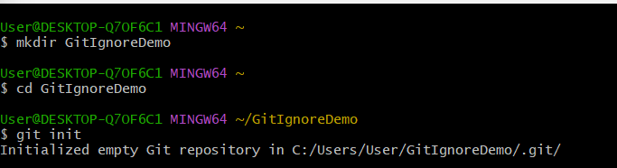

**Step 2: Create files and folders**

We create a .log file, a log folder containing another .log file, and a README.md. These will be used to demonstrate the ignore feature. We can create in main or master also.

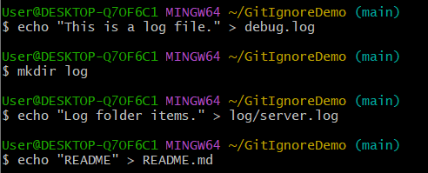

**Step 3: Create .gitignore file**

This tells Git to ignore all .log files and the entire log directory.

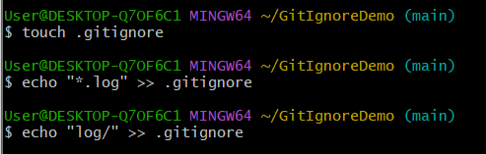

**Step 4: Check status of Git**

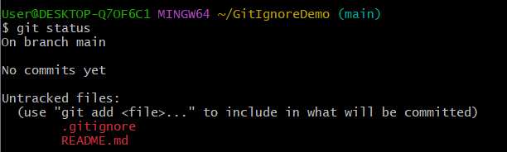

You can’t see debug.log or log/ in files because they’re ignored.

**Step 5: Add the commit the trackable files**

We add and commit the visible i.e. non-ignored files to repository.

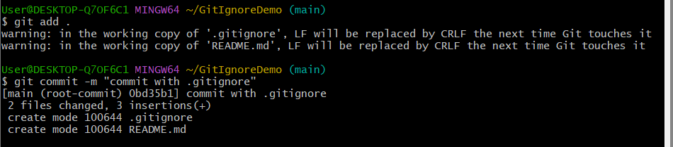

**Step 6: We can verify Ignored files**

We can see them in directory but Git will ignore them.

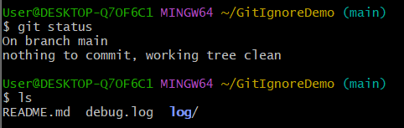

**Step 7: Verification**

